October | 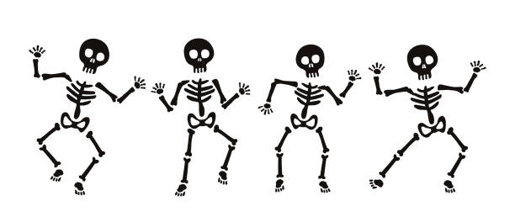
 | 2023
Sunday | Monday | Tuesday | Wednesday | Thursday | Friday | Saturday
1 | 2 | 3 | 4 | 5 | 6 | 7
 |  | Senior Lunch 11:30 |  | Yoga  9:00 am
8 | 9 | 10 | 11 | 12 | 13 | 14
 |  | Senior Lunch 11:30 |  | Yoga  9:00 am
15 | 16 | 17 | 18 | 19 | 20 | 21
 |  | Senior Lunch 11:30 |  | Yoga  9:00 am |  | Fall Clean-up  Dumpsters at Parks
22 | 23 | 24 | 25 | 26 | 27 | 28
Fall Clean-up  Dumpsters at Parks |  | Senior Lunch 11:30 |  | Yoga  9:00 am | 
29 | 30 | 31
 |  | Senior Lunch 11:30  Trunk-or-Treat  Slaterville Park | 
 |  | 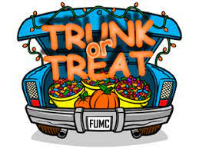 |  |  |  |   Veterans Dinner  Nov 3rd

