November  November |  |  |  | 2024
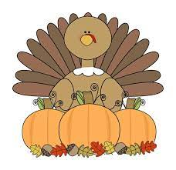
202204
Sunday | Monday | Tuesday | Wednesday |  | Thursday | Friday | Saturday
 |  |  |  |  |  | 1 | 2

3 | 4 | 5 | 6 |  | 7 | 8 | 9
 |  |   Senior Lunch 11:30 |  |  | Yoga  9:00 | Veteran’s Day Dinner  6:00 – 7:30  Jeremiahs Lodge
10 | 11 | 12 | 13 |  | 14 | 15 | 16
 |  | Senior Lunch 11:30 |  |  | Yoga  9:00 | Holiday Craft Fair  City Building  3:00 pm – 7:00 pm | Holiday Craft Fair  City Building  10:00 am – 3:30 pm
17 | 18 | 19 | 20 |  | 21 | 22 | 23
 | City Office  Closed  Veteran’s Day Nov 11th | Senior Lunch 11:30 |  |  | Yoga  9:00
24 | 25 | 26 | 27 |  | 28 | 29 | 30
 |  | Senior Lunch 11:30 |  |  | 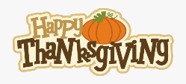 | 
 |  |  |  |  |  | Breakfast with Santa  Sat Dec 14th  9:00 – 11:00 am | Please RSVP with the City Office  801-627-1919  By Dec 10th

